SPRINT_1

|  |  |
| --- | --- |
| **Date** | 1 November 2022 |
| **Team ID** | PNT2022TMID08745 |
| **Project Name** | Smart Farmer - IoT Enabled Smart Farming Application |
| **Maximum Marks** | 4 Marks |

#include <Servo.h> Servo s; int Sensor

= 0; int data = 0; int motorPin = 9;

void setup()

{

Serial.begin(9600); pinMode(A0,INPUT);

//Temperature Sensor pinMode(A1,INPUT); //Soil Moisture Sensor pinMode(10,OUTPUT);

//GREEN light for LED pinMode(11,OUTPUT);

//BLUE light for LED pinMode(12,OUTPUT);

//RED light for LED s.attach(3);

//Servo Motor

pinMode(motorPin, OUTPUT); //DC motor

} void loop(){

Sensor = analogRead(A1); //Reads data from Soil Moisture sensor data = map(Sensor,0, 1023, 0, 100); //Low analog value indicates HIGH moisture level and High analog value indicates LOW moisture level

//data = map(analogValue,fromLOW,fromHIGH,toLOW,toHIGH) Serial.print("Soil Moisture value:");

Serial.println(data);

//'data = 0' indicates wet and 'data = 100' indicates dry

double a = analogRead (A0); //Reads data from Temperature sensor double t = (((a/1024)*5)-0.5)*100; Serial.print("Temperature value:"); Serial.println(t);

if (t>40 & t<50){ digitalWrite(10,0); digitalWrite(11,1); digitalWrite(12,0); s.write(90);

digitalWrite(motorPin, HIGH); Serial.println("Water Partially Flows");

}

else if (t>50){ digitalWrite(10,0); digitalWrite(11,0); digitalWrite(12,1); s.write(180);

digitalWrite(motorPin, HIGH); Serial.println("Water Fully Flows"); }

else if (t>30 & data<30){ digitalWrite(10,1); digitalWrite(11,1); digitalWrite(12,0); s.write(90); digitalWrite(motorPin, HIGH); Serial.println("Water Partially Flows");

}

else if (data<50){ digitalWrite(10,0); digitalWrite(11,1); digitalWrite(12,1); s.write(90); digitalWrite(motorPin, HIGH); Serial.println("Water Partially Flows");

}

else{ digitalWrite(10,1); digitalWrite(11,0); digitalWrite(12,0); s.write(0); digitalWrite(motorPin, LOW); Serial.println("Water Does Not Flow");

}

Serial.println(" ");

delay(1000);

}

# Circuit Diagram

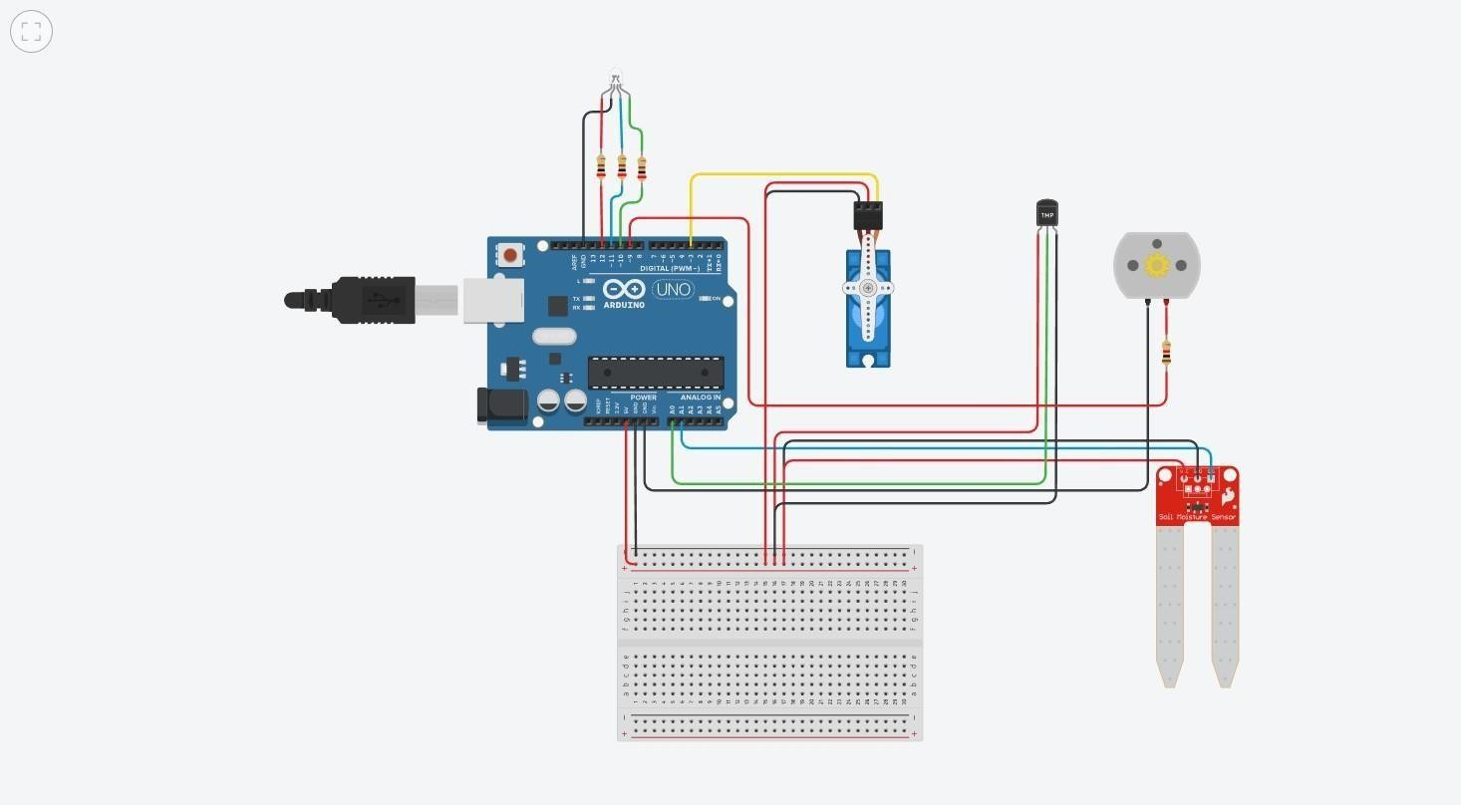

**Components Used**

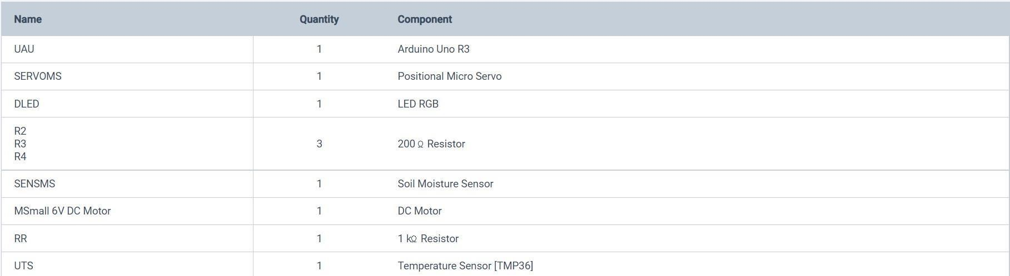

# Schematic View

